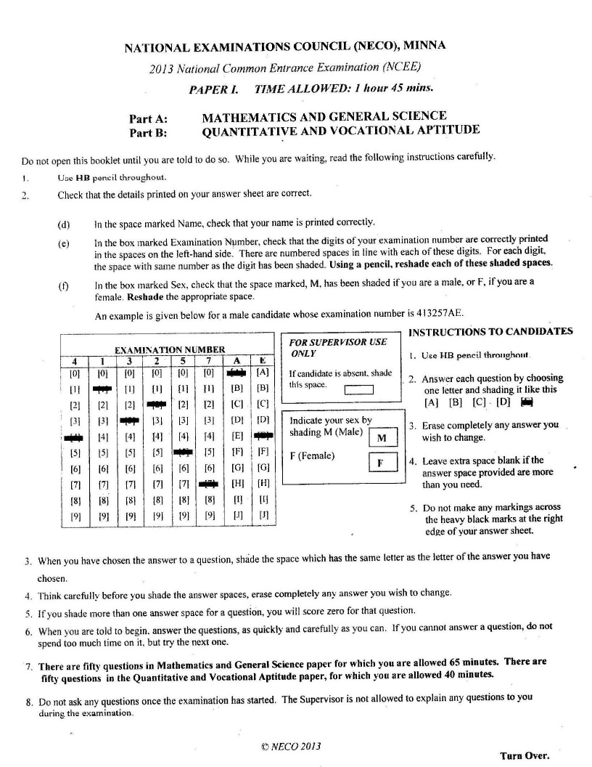

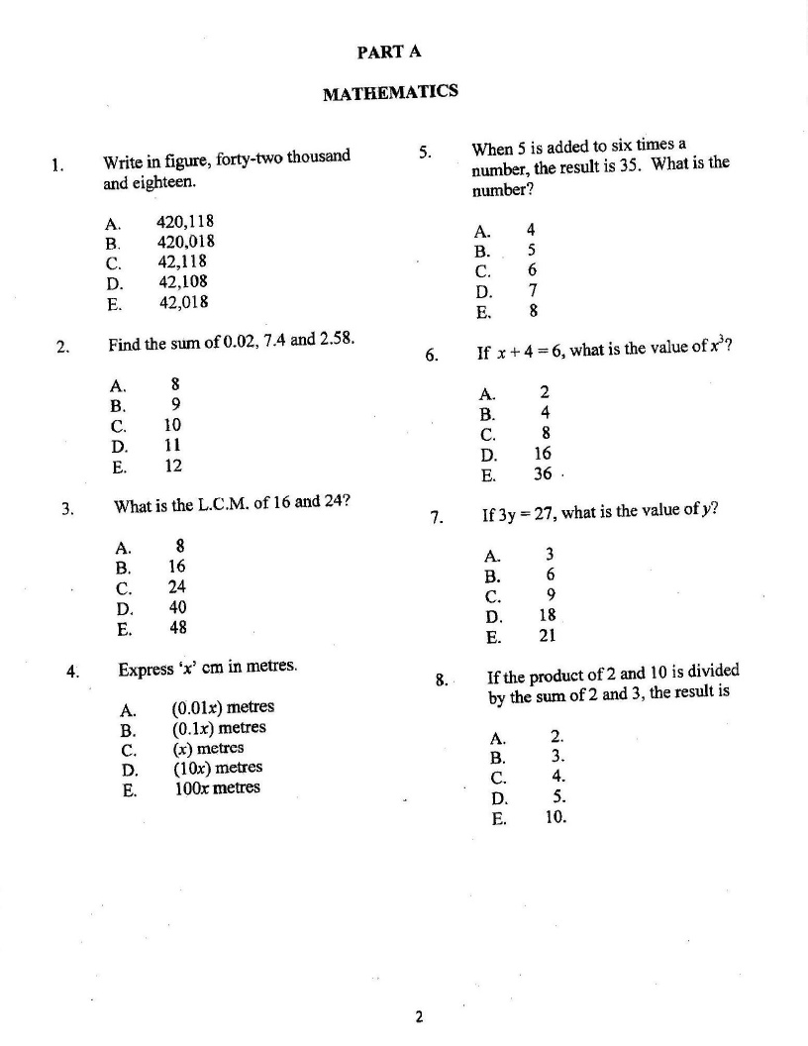

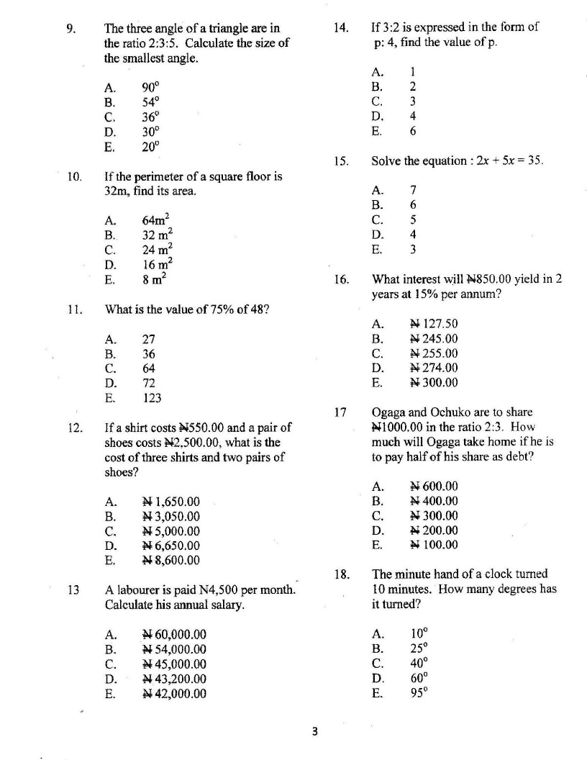

1. Triangle LMN below has height “hcm” and area 60cm² . Find h

L

h

M N

20cm

1. 20cm (b) 18cm (c) 9cm (d) 6cm (e) 3cm
2. If 2(3 + q) = 18; Find the value of q.
3. 2 (b) 4 (c) 6 (d) 8 (e) 10
4. What is the interest of N500 for 5years at the rate of 5% per annum?
5. N125 (b) N115 (c) N105 (d) N100 (e) N75 0
6. If 500 oranges were shared among Taiwo, Kehinde and Musa in the ratio of 3:3:4 respectively, What Musa’s share? (a) 400 (b) 300 (c) 200 (d) 150 (e) 100
7. Find the LCM of 2, 3, 4, 5 and 7.

(a) 68 (b) 75 (c) 95 (d) 105 (e) 210

1. Find the value of X if 5 – 8X = 29.

(a) -3 (b) -2 (c) 0 (d) 2 (e) 3

1. A three – sided plane is called a _______________.
2. Decagon (b) Octagon (c) Pentagon (d) Rectangle (e) Triangle
3. Find the H,C,F of 15 , 18 and 24.
4. 3 (b) 6 (c) 30 (d) 45 (e) 120
5. If x = 3, y = 5 and z = 1, find the value of xy – yz.
6. – 15 (b) -10 (c) 10 (d) 15 (e) 20
7. In the figure below, calculate the value of K.

K (a) 7 (b) 5 (c) 4 (d) 3 (e) 2

4

3

1. Dada borrowed N2000 from his friend at the rate of $2\frac{1}{2}\%$ per annum simple interest. Find the amount he will pay back to his friend after two years.
2. N1,950 (b) N2,050 (c) N2,100 (d) 2,500 (e) N3,100
3. Adamu bought some quantity of salt at N90 at a tone and sold it at 8K per kilogram. How much did he lose or gain?
4. N10.00 gain (b) N10.00 loss (c) N80.00 gain (d) 82.00 loss (e) N82.00 gain
5. There are 45 children in a class, if 9 of them are absent, what percentage of the class is absent?
6. 90% (b) 80% (c) 36% (d) 20% (e) 9%

51⁰

Find x.

1. 45⁰ (b) 60⁰ (c) 51⁰ (d) 59⁰ (e) 90⁰

X⁰ 70⁰

1. Calculate the area of the semi circle below ( take $π$ = $\frac{22}{7}$)

**P 14cm Q** (a) 70cm (b) 77cm (c) 80cm (d) 85cm (e) 90cm



1. Approximate 50, 769 in it’s nearest hundred.
2. 50,000 (b) 50,700 (c) 50,760 (d) 50,770 (e) 50,800
3. The average speed of a journey of 1,440km was 80km/h. How long did the journey last?
4. 3hours (b) 6 hours (c) 12 hours (d) 18 hours (e) 24 hours
5. The class is made up of 50Boyys and 25Girls. What is the ratio of Girls to Boys?
6. 1:2 (b) 2:1 (c) 2 : 5 (d) 5 : 2 (e) 7 : 2

Q R

6cm

P T 8cm S

**Use the above Trapezium to answer questions 37 - 39 .**

1. What is the area of triangle PQT?

(a) 24cm² 9b) 14cm²(c) 12cm²

1. What is the area of the rectangle QRST?

(a) 36cm² (b) 24cm² (c) 48cm²

1. What is the area of the trapezium? _______ (a) 56cm² (b) 40cm² (c) 60cm²
2. If m = 4 and n = 3, what is the value of (m + n ) ( m – n )?
3. 27 (b) 14 (c) 8 (d) 7 (e) 6

***BASIC SCIENCE***

1. Which of the following is NOT a sense organ?
2. Heart (b) Eye (c) Tongue (d) Skin (e) Nose
3. The path along which a planet travels around the sun is called ____.
4. Eclipse (b) Orbit (c) Solar system (d) Radar (c) Satellite
5. Which of the following is non – metal?
6. Iron (b) Aluminum (c) Gold (d) Plastic (e) Zinc
7. The process by which plants manufacture food is known as ______.
8. Osmosis (b) Respiration (c) Photosynthesis (d) Phototropism (e) Transpiration
9. The instrument used to measure the temperature of an object is known as a ______.
10. Barometer (b) Hydrometer (c) Thermometer (d) Potentiometer (e) Hygrometer
11. Which of the following conducts heat best?
12. Wood (b) Water (c) Paper (d) Glass (e) iron
13. The process by which water vapour is changed to cloud is called _____.
14. Condensation (b) Vaporization (c) Oxygenation (d) Saturation (e) Evaporation
15. Objects that allow electricity to pass through them are called _____.
16. Transformers (b) fathers (c) Conductors (d) Passers (c) Takers
17. Which of the following has a high affinity for water ?
18. Sandy soil (b) Loamy (c) Clay (d) Humus (e) Literate
19. Where in the plant is the food produced?
20. Flowers (b) Root (c) Stem (d) Seed (e) Leaf